**7.USING SET OPERATORS**

**Name: Eniya . B.A**

**Roll no:230701085**

1.The HR department needs a list of department IDs for departments that do not contain the job ID ST_CLERK. Use set operators to create this report.

QUERY:

select Department_id from employees

minus

select Department_id from employees where Job='stock clerk';

OUTPUT:

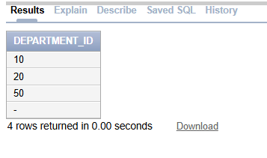

2. The HR department needs a list of countries that have no departments located in them.

Display the country ID and the name of the countries. Use set operators to create this report.

QUERY:

select Country,Country_id from employees

minus

select Country,Country_id from employees where Department_id is NULL;

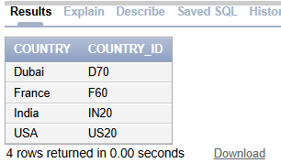

1. Produce a list of jobs for departments 10, 50, and 20, in that order. Display job ID and department ID using set operators.

QUERY:

SELECT Job_id, Department_id

FROM employees

WHERE Department_id = 10

UNION

SELECT Job_id, Department_id

FROM employees

WHERE Department_id = 50

UNION

SELECT Job_id, Department_id

FROM employees

WHERE Department_id = 20;

OUTPUT:

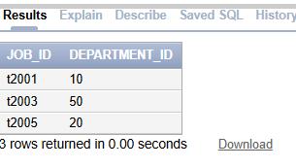

4. Create a report that lists the employee IDs and job IDs of those employees who

currently have a job title that is the same as their job title when they were initially

hired by the company (that is, they changed jobs but have now gone back to doing

their original job).

QUERY:

SELECT Emp_id, Job_id

FROM employees

INTERSECT

SELECT Emp_id, Job_id

FROM Job;

OUTPUT:

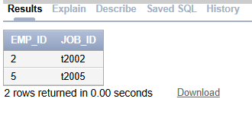

5. The HR department needs a report with the following specifications:

- Last name and department ID of all the employees from the EMPLOYEES table, regardless of

whether or not they belong to a department.

- Department ID and department name of all the departments from the DEPARTMENTS table,

regardless of whether or not they have employees working in them Write a compound query to

accomplish this.

QUERY:

SELECT

Last_name ,

Department_id ,

TO_CHAR(NULL)

FROM employees

UNION ALL

SELECT

TO_CHAR(NULL),

id ,

Dept_name

FROM Department;

OUTPUT:

